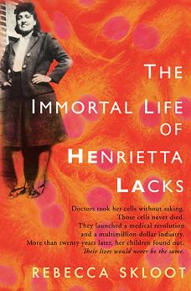
SUMMER READING ASSIGNMENT FOR PREAP BIOLOGY:

ALL PREAP AND GT PREAP BIOLOGY STUDENTS WILL BE REQUIRED TO READ THE IMMORTAL LIFE OF HENRIETTA LACKS BY REBECCA SKLOOT. DURING OUR UNIT ON CELL DIVISION, STUDENTS WILL CREATE A VISUAL REPRESENTATION OF A THEME FROM THE BOOK THAT CAN BE APPLIED TO BIOLOGY. THE PROJECT WILL BE WORTH ONE SUMMATIVE GRADE. DIRECTIONS WILL BE GIVEN IN CLASS DURING THE CELL DIVISION UNIT (OCTOBER/ NOVEMBER).

